Prince Tower.

1. Project Information
- Project Name: Prince Tower
- Location: Dharavi, Mumbai
- Plot Area: __________________
- Built-up Area: __________________
- Project Type: High-rise residential redevelopment
- Client/Developer: Punit Construction
- Architect: Wall Voids Architects
- Status: __________________

2. Project Overview
Prince Tower is a high-rise residential redevelopment planned within an existing structural framework. The original plinth and columns were retained while the internal planning, circulation and façade were completely refined. The tower combines efficient residences with a distinctive contemporary architectural identity.

3. Building Features
- Curved balconies with glass railings
- Floor-to-ceiling windows and extensive glazing
- Repetitive white architectural frames
- Warm wooden balcony soffits
- Ground-level commercial frontage
- Landscaped entrance and pedestrian areas
- Integrated façade lighting
- Sculptural landscaped rooftop crown

4. Design Concept
The architecture uses continuous curved balcony bands to soften the vertical scale of the tower. White structural frames, transparent glazing and warm finishes create a fluid and elegant façade. The sculptural rooftop feature gives the building a strong and recognisable skyline identity.

5. Special Planning Features
- Existing constructed plinth and columns retained
- Five efficiently planned residences on a typical floor
- Central circulation core with four lifts
- Separate staircases for circulation and fire safety
- Two open-to-sky courts for light and ventilation
- Wide lift lobby and connecting passages
- Curved apartment planning along the external façade
- Improved layouts within the existing structural constraints
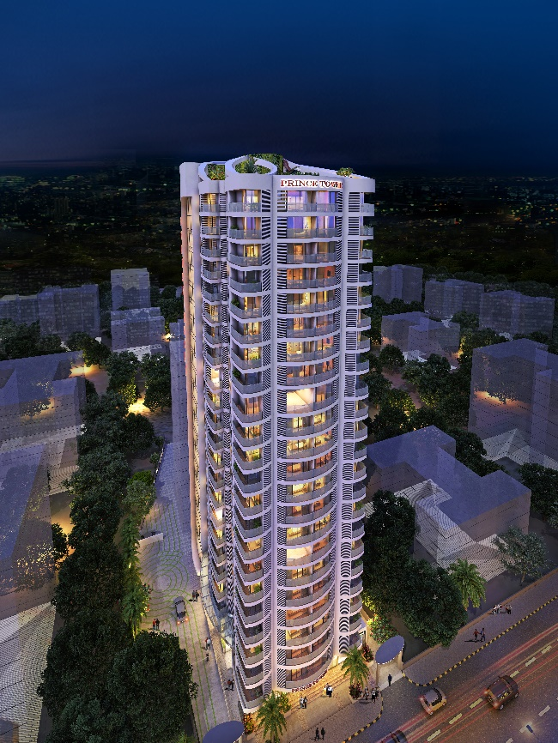
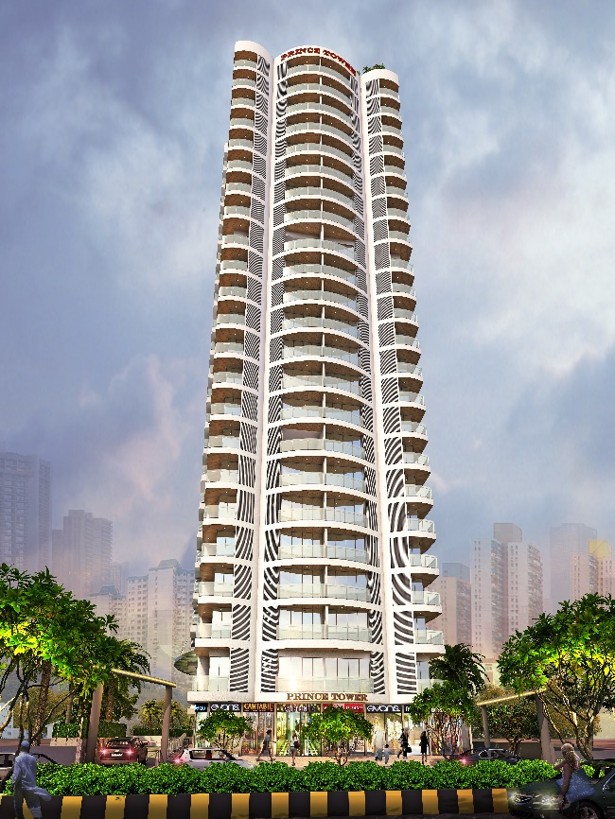
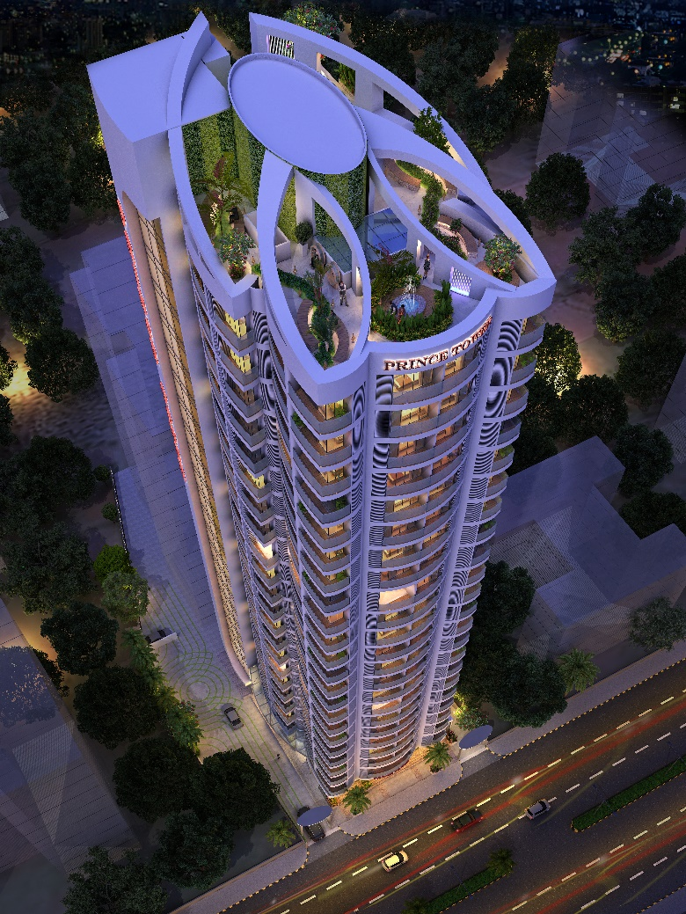
Image 1
Image 2
Image 3

